**DAILY ONLINE ACTIVITIES SUMMARY**

|  |  |  |  |  |  |  |  |  |
| --- | --- | --- | --- | --- | --- | --- | --- | --- |
| **Date:** | 04-06-2020 | | | | | **Name:** | D Richard Franklin | |
| **Sem & Sec** | Fourth sem section A | | | | | **USN:** | 4AL18CS020 | |
| **Online Test Summary** | | | | | | | | |
| **Subject** | | Micro controller and embedded system | | | | | | |
| **Max. Marks** | | 20 | | **Score** | | | 16 | |
| **Certification Course Summary** | | | | | | | | |
| **Course** | **Python and Django Full Stack Web Developer Bootcamp** | | | | | | | |
| **Certificate Provider** | | | Udemy | | **Duration** | | | **3 hr** |
| **Coding Challenges** | | | | | | | | |
| **Problem Statement:**  1: Finding some of three numbers  2: Write a C++ program to find the missing number in array | | | | | | | | |
| **Status:** completed | | | | | | | | |
| **Uploaded the report in Github** | | | | | yes | | | |
| **If yes Repository name** | | | | | <https://github.com/alvas-education-foundation/Richard_Franklin> | | | |
| **Uploaded the report in slack** | | | | | yes | | | |

**Online Test Details:**

MES test was scheduled from 02:00pm to 2:30pm. The portion for the IA was 3rd module there were 20 questions and the time assigned was 30minutes the questions were MCQ type. I scored 16/20.

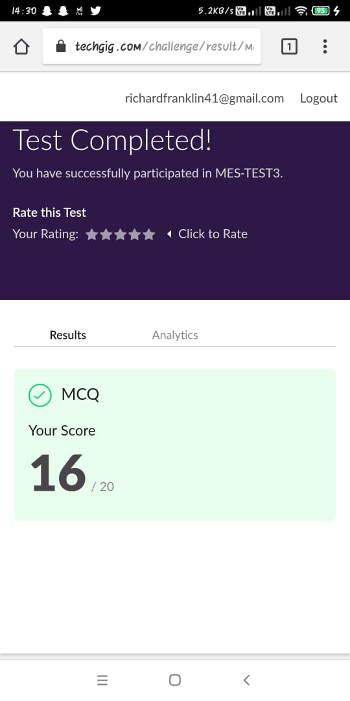

**Online Course Details:**

Name of course: **Python and Django Full Stack Web Developer Bootcamp**

Certificate provider: udemy

This section was about the advance properties of CSS it was about how use different fonts download it from external source and apply it. It also explained the boxing concept.

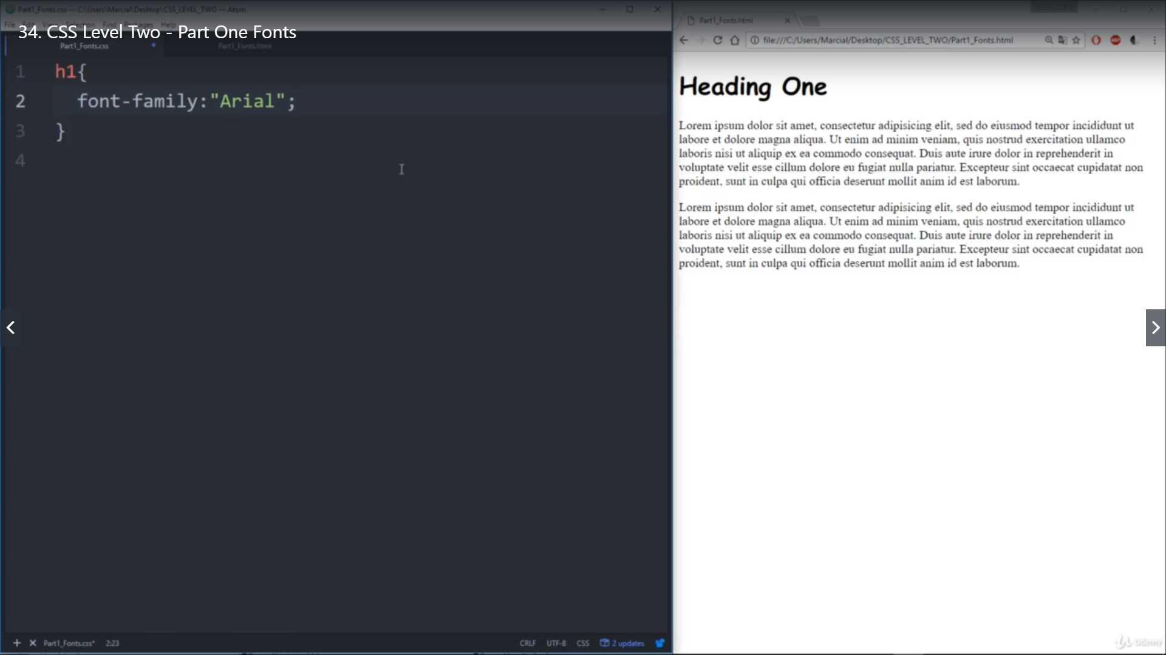

**Online coding:**

Problem 1: (using Java) write a java program to read three integer values from the keyboard and find the sum of the values. Declare a variable "sum" of type int and store the result in it.

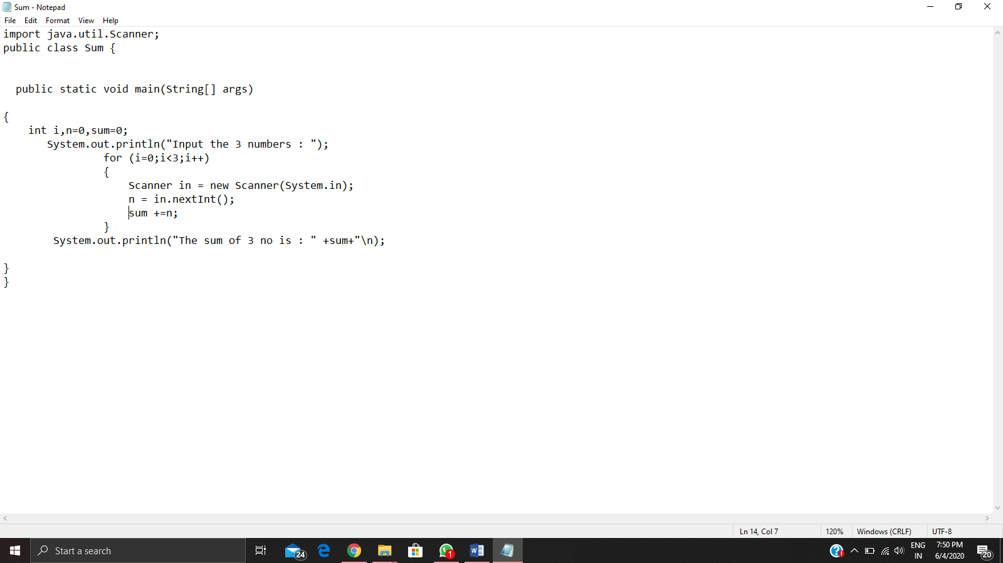

Problem 2: (using C++) Write a C++ program to find the missing number in array

